The Deepening Crisis in Enforcement

David Whyte, University of Liverpool

This paper explores the features of, and the political developments that lie behind a collapse in the use of prosecutions following health and safety offences. It begins by reviewing HSE published data and data obtained by Freedom of Information requests in order to build a picture of the extent of this collapse. The paper ends by placing those trends in the context of recent policy shifts.

In the immediate period following the election of the Labour government in 1997, there appears to have been a renewed enthusiasm for enforcement in key regulatory agencies. Between 1997/98 and 1999/00, HSE prosecutions rose by 20%. In the Environment Agency, prosecutions rose by 48% between 1999 and 2002. There appears also to have been a sharp rise in local authority health and safety enforcement in the first year of the Labour administration (see Figure 1). If this was a response that can be described a moment of momentum spurred by the removal from office of the government that waged a ‘bonfire of red tape’ and, at a rhetorical level at least, sought to reposition regulation as a ‘burden on business’ that governments should strive to minimise, it was short lived.

FIGURE 1: HSE and Local Authority Health and Safety Enforcement

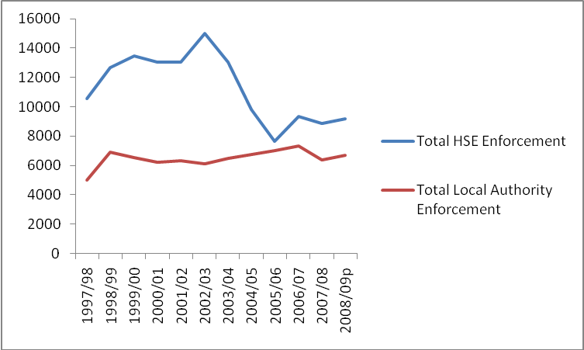

The graph set out in Figure 1 shows how a decline in HSE enforcement activity has been accompanied by a marginal rise in enforcement by local authorities. Perhaps most notable in this graph is that the trend in HSE enforcement is distinguished by two plateaux in activity: a relatively high plateau (between 1998/99 and 2003/04) and a sharp decline (between 2003/04 and 2005/06) to a relatively low plateau (between 2005/06 and 2008/09).
FIGURE 2: HSE and Local Authority Health and Safety Prosecutions

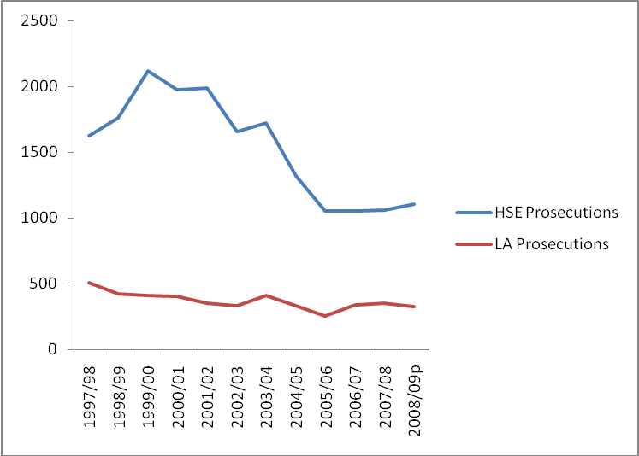

Figure 2 shows the trends in prosecutions within the broader trends represented in Figure 1. This figure shows that the decline in HSE prosecutions has been much more rapid than the decline in prosecutions by local authorities. Since 1997/98, HSE prosecutions have declined by 32% and local authority prosecutions by 34%. What is also apparent from Figure 1 is that both experienced their most dramatic short-term decline in this period between 2003/04 and 2005/06 (39% and 20% respectively) before levelling off at a relatively low rate for the past 3 years.

FIGURE 3: Trends in HSE Enforcement Notices

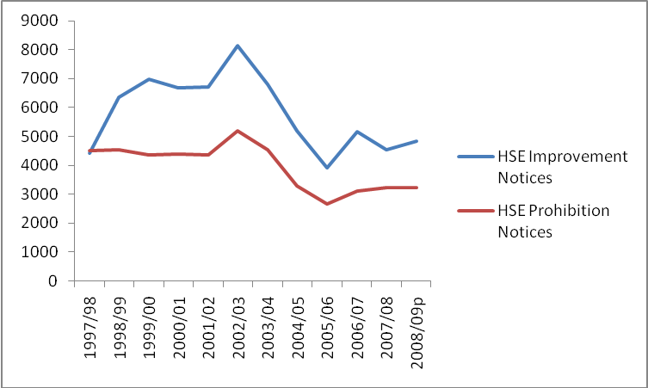

There appears to have been a sharp increase in the use of improvement notices from the beginning of the first Labour government to the beginning of the second (an increase of 46% between 1997/98 and 2002/03). The use of prohibition notices does not exhibit the same steep rise in 1997/98, but remains constant for 5 years or so. There follows a slight rise from 2001/02, and then a 4 year decline, before the trend appears to stabilise at relatively low rate in the past couple of years. The data on prohibition notices reveals it to be a more stable form of enforcement action than prosecutions or improvement notices, albeit one that has declined substantially since 1997/08.

The use of improvement notices, despite this form of enforcement appearing to be a more volatile form of enforcement action, has actually risen by 10% since 1997/98. This compares to a 29% decline in prohibition notices, and, as we have seen, a 32% decline in prosecutions in the same period. The decline in the rate of prohibition notices issued, as indicated in Figure 3, when considered alongside a similar decline in prosecutions indicated by Figure 2, may indicate a tendency to use improvement (even in a less enforcement-minded context) notices in place of more severe forms of enforcement option.

FIGURE 4: Total RIDDOR reports to HSE and other authorities

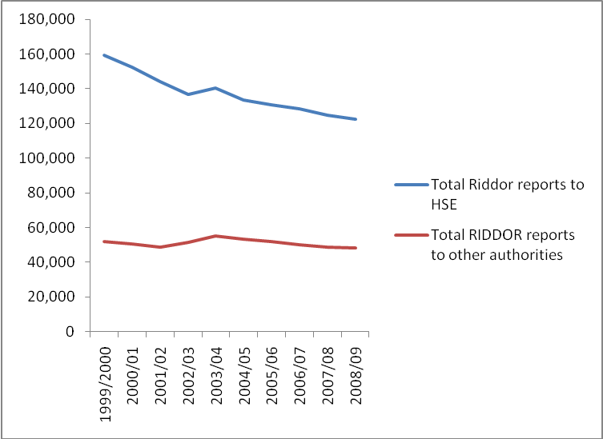

What Figure 4 indicates is that there have been a relatively marginal decline of RIDDOR reports to local authorities (of 7% between 1999/00 and 2008/09) and a more steady decline in such reports to the HSE (by 23% in the same period). A decline in RIDDOR reports may be related to a number of factors. It may well reflect a real decline in incidents and breaches. But even if this is the case such a decline can result from a number of factors un-related to compliance or better safety management on the part of duty holders, such as a decline in particular forms of work or industrial activity, or indeed a decline in the number of employees in particular industries and so on.

Overall, then, it appears from the evidence we have seen so far that there appears to be a significant decline in both RIDDOR reports and in enforcement action. The rest of this paper is concerned primarily with analysing those trends in the HSE.

Whilst RIDDOR reports contribute to a relatively small proportion of enforcement action (typically 5%-7% of enforcement notices result from RIDDOR reports; and typically between a quarter and a third of prosecutions), it is possible that declining reporting rates may be influencing a decline in enforcement. This hypothesis would be that there is a direct correlation between the reduction of RIDDOR reports and the real number of detected offences that require an enforcement response.

FIGURE 5: HSE Investigations as a % of RIDDOR Reports

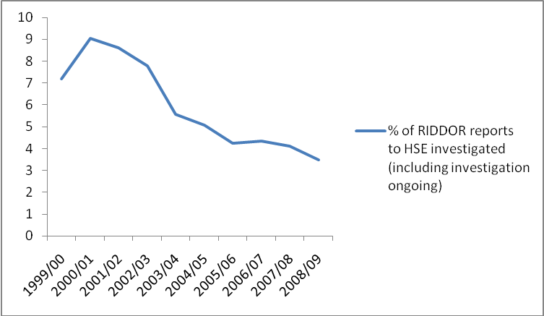

If the decline in RIDDOR reports to HSE indicated by Figure 5 does raise the question that a general decline in HSE enforcement activity is exclusively the result of a general decline in RIDDOR reporting, this hypothesis is rejected squarely by the data in Figure 5. The proportion of reports investigated since 1999/2000 has halved. Measured in numbers of investigations, this represents a decline from 11,462 in 1999/00 to 4272 in 2008/09 (or a 63% decline in investigations). In fact the decline in the rate of RIDDOR investigations is slightly steeper than the general decline in enforcement activity.

The other main source of cases that prompt an enforcement response are those cases that come to the attention of HSE through routine investigation and monitoring work. Comprehensive evidence of this activity is not currently available. But we do have some concrete indicators to draw upon. Figures released recently following a Freedom of Information request to the HSE by Hazards Magazine show how, in the Field Operations Directorate, the largest division of the HSE, there was a 26 per cent fall in inspections and a 19 per cent fall in regulatory contacts between 2002-2003 and 2004-2005. More recent research reveals a yet more dramatic collapse in regulatory activity over a longer period of time. This research shows that investigations of major injuries fell by 43% between 2001/02 and 2006/07. In 2006/07, HSE investigated only a third of the number of over three-day injuries they investigated in 2001/02 and only a quarter of major injuries to members of the public that they investigated in 2001/02.

If we return to our data on enforcement following RIDDOR reports, what is particularly notable is that between 1999/00 and 2004/05, prosecutions expressed as a proportion of RIDDOR reports represented the primary enforcement response. Between 2004/05 and 2007/08, this trend is reversed, and prosecutions go into steady decline. In 2007/08, enforcement notices expressed as a proportion of RIDDOR reports represented are twice as likely to be used than prosecutions.

FIGURE 6: HSE Enforcement as a % of RIDDOR Reports

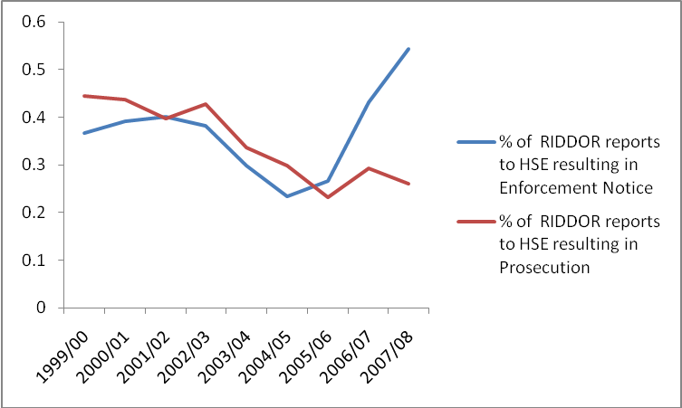

What all of this tells us is that there is something dramatic taking place in HSE enforcement practice, something that is best described as a collapse in prosecution. This collapse can be identified as becoming particularly embedded at the beginning of Labour’s second term in office. Thus, a rapid decline in HSE enforcement action generally is apparent from 2002/03 (see Figures 1 and 3) and in particular, the most recent sharp decline in prosecutions begins in 2003/04 (Figure 2). Moreover, the collapse in prosecution evident in RIDDOR prosecutions (Figure 6) also appears to begin in 2002/03. It is valid, then, to ask what features of government policy and policy within the HSE that may have led to this collapse.

First, of all, from 2002 onwards, the steady erosion of HSE resources is clearly a factor. Between 2002 and 2008, HSE has experiences a staff-in-post reduction of 16%. In 2008, HSE had 1,323 frontline operational inspectors (12% less than the 2002 total). But this decline in resourcing has been coupled to a much broader attack on enforcement that began in Labour’s first term, but gained momentum in the second Labour government.

The first Labour government had consolidated the Conservatives ‘burdens on business agenda’ with the renaming of the Conservative’s flagship Deregulation Unit as the ‘Better Regulation Unit’. It also established a ‘Better Regulation Task Force’ in the Cabinet Office at the heart of government. The Task Force was charged with precipitating deregulatory measures across government, perhaps the most significant measure being the introduction of regulatory impact assessments. But it was not until Labour’s second period of office that it became clear how deep the attack on regulatory enforcement was going to get. A key moment came in November 2003 when the government ditched its proposed Safety Bill and with it went the long promised introduction of the power of provisional enforcement notices for workplace safety representatives.

In 2004 the extent of New Labour’s long-term plans for a reconstructed system of business regulation became fully apparent when Gordon Brown appointed the Chairman of J Sainsbury Philip Hampton to lead a wholesale review of business regulation. On announcing the Hampton review, Brown famously called for not just a ‘light touch’, but for a ‘limited touch’ in regulation. The Hampton Report – published a year later called for greater emphasis on advice and education and for a removal of the ‘burden’ of inspection from most premises. Specifically, Hampton called for the reduction of inspections by up to a third across all regulatory agencies. In practice this proposal was for 1 million less inspections; in their place regulators were to make much more ‘use of advice’ to business.

The Hampton reforms have at their heart a very carefully constructed rationale which defines regulation first and foremost in terms of its economic burden on business. Thus, section 1 of the Act creates a remarkable new power for a Minister of the Crown to make an order that removes from government a “regulatory burden”, defined in the Act as a “financial cost”, an “administrative inconvenience” or “an obstacle to efficiency, productivity or profitability”. There is a very unashamed and open honesty about the language being used here; we now find in legislation and in policy a very open admission that there is a direct relationship between the shift towards self-regulation and a neo-liberal profit-maximising agenda. Hampton’s recommendations are also based upon a carefully framed ‘targeted intervention’ approach, which in turn is based upon the assumption that the majority of duty holders are generally compliant and only the minority need the ongoing scrutiny of the regulator. In July 2005, the HSC launched its own review of regulation under the rubric of ‘a debate on the causes of risk aversion in health and safety’; its draft ‘simplification’ plans, published in four months later, it outlined its strategy to follow to the letter the Hampton recommendations. In this document, HSC promised a ‘risk-based, targeted approach to enforcement’ that was to be supported by a 33 per cent reduction in inspections (HSC/E, 2005).

The explicit economic rationale at the heart of the Hampton reforms reached their high point in the new Regulators Compliance Code, published in December 2007, by the newly formed Department for Business, Enterprise and Regulatory Reform. This Regulatory Code was introduced to address how ‘the few businesses’ (Para. 8) that break the law should be handled. In general, regulators, including the HSE, were advised they ’should seek to reward those regulated entities that have consistently achieved good levels of compliance through positive incentives, including lighter inspections and less onerous reporting requirements‘ (Para. 8.1). If the rationale for these new realities of regulation was not clear enough, the document formalised the emerging conflict of interest for regulatory bodies when it emphasised that ’[r]egulators should recognise that a key element of their activity will be to allow, or even encourage, economic progress and only to intervene when there is a clear case for protection’ (Para. 3). Thus the Hampton Review and the reforms that followed have extended the scope and reach of the burdens on business agenda directly into the day-to-day work of inspectors, further marginalising the enforcement role of the HSE and giving renewed momentum to New Labour’s pro-business trajectory.

The politics that stands behind Labours regulatory reforms, then, combines elements of neo-liberal economic rationale alongside a naive assumption that effective self-regulation by businesses is possible. The regulatory degradation that Labour has ensured is based upon politically expedient concepts of ‘risk-based’ and ‘targeted intervention’ , or the idea that only the minority of offenders require scrutiny or intervention. In the meantime, a clear message is being sent to all employers: that serious offences against workers and members of the public will continue to go unpunished.

This paper is based upon an ongoing long-term research project on health and safety enforcement in collaboration with Steve Tombs of Liverpool John Moores University. This paper develops arguments first set out in Crisis in Enforcement (2007, Centre for Crime and Justice Studies) and in ‘A Deadly Consensus’, an article published in the current issue of the British Journal of Criminology (vol 50, no 1).
Figures 1-3 present a secondary analysis of HSE enforcement figures, available online at: http://www.hse.gov.uk/statistics/enforce/index.htm. Figures 4-6 present a secondary analysis of data supplied to the author on 2nd February 2010 as part of a Freedom of Information request to the Health and Safety Executive.
UNITE/CCA (2008) Lack of Investigation 2001/2007, London: UNITE, http://www.corporateaccountability.org/dl/HSE/investig/unite.pdf

